Name _____________________________________

Types of Selection

A group of snakes were all placed into environments that had differing selective pressures. Read the data tables below and graph each snake in its environment. From the graph, determine what type of selection is being portrayed: directional, stabilizing or disruptive.

1. Snakes placed on an island where there are two predators that eat snakes.

|  |  |  |  |  |  |  |
| --- | --- | --- | --- | --- | --- | --- |
| Number of Snakes at Each Length | | | | | | |
|  | | 2 cm | 4cm | 6 cm | 8 cm | 10 cm |
| Year | 1980 | 2 | 8 | 14 | 12 | 4 |
| 1984 | 4 | 12 | 8 | 9 | 8 |
| 1988 | 10 | 6 | 3 | 6 | 14 |

Graph

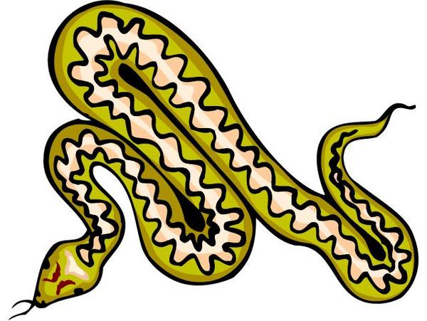

Type of Selection:

Summarize what happened to the snakes.



2. Snakes placed on an island where there is only one size of burrow available to the snakes to live in.

|  |  |  |  |  |  |  |
| --- | --- | --- | --- | --- | --- | --- |
| Number of Snakes at Each Length | | | | | | |
|  | | 2 cm | 4cm | 6 cm | 8 cm | 10 cm |
| Year | 1980 | 3 | 6 | 7 | 8 | 5 |
| 1984 | 4 | 5 | 13 | 5 | 3 |
| 1988 | 1 | 3 | 15 | 2 | 1 |

Graph



Type of Selection:

Summarize what happened to the snakes.



3. Snakes placed on an island where there is only one predator, a snake eating toad. This toad can only eat snakes under 6 cm long

|  |  |  |  |  |  |  |
| --- | --- | --- | --- | --- | --- | --- |
| Number of Snakes at Each Length | | | | | | |
|  | | 2 cm | 4cm | 6 cm | 8 cm | 10 cm |
| Year | 1980 | 4 | 10 | 14 | 8 | 7 |
| 1984 | 2 | 6 | 8 | 12 | 8 |
| 1988 | 1 | 2 | 3 | 15 | 9 |

Graph



Type of Selection:

Summarize what happened to the snakes.



*Revisions 11/16/2010 by 7th Hour (C.S & K.K)*